FIFO Draft Automation

Step 1: Download Aged Serialized Inventory Report For Location Sun Com Mobile LLC And Vendor Ingram Micro form RQ4 and delete unnecessary fields and format the sheet look like

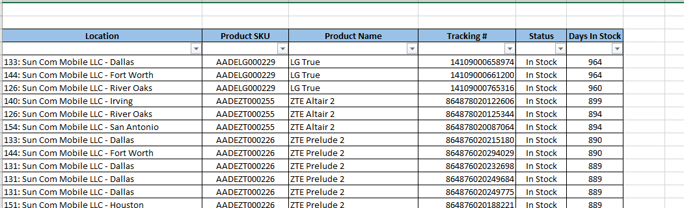

Note : Including row spaces

Step 2: To open VBA editor Press Alt+ F11 and navigate to FIFO_Draft() or similar function name

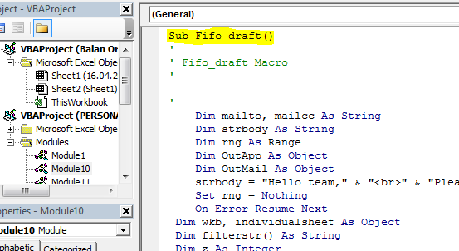

Step 3: Check location mail list xlsx file is present in the directory and ensure that book has updated mail list

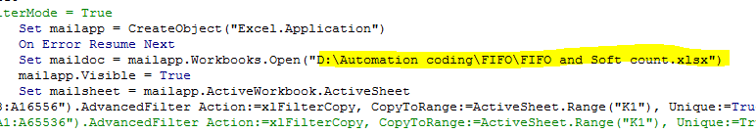

Step 4: Ensure that I has minimum value three in coding

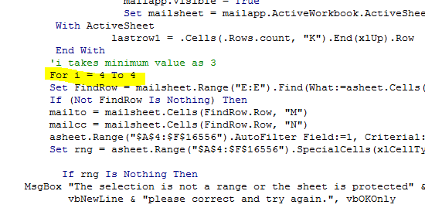

Step 5 : Click Run to get the outlook window

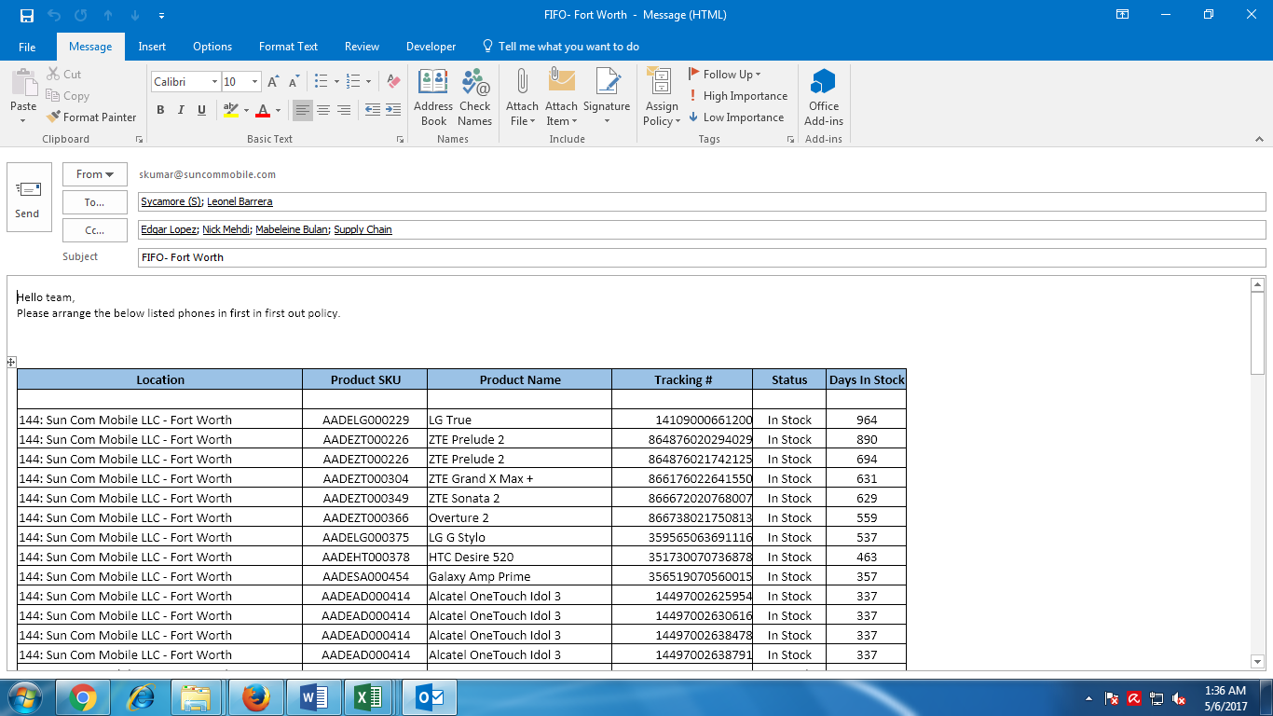

Note : If u need 5 reports at a time change for as

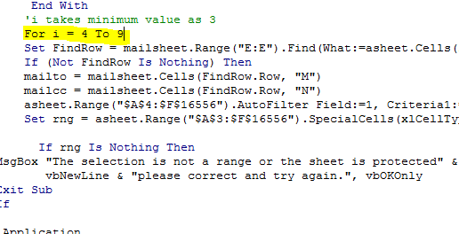

If u need all location as draft change for loop like

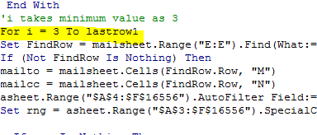

It will display all drafts

Instead of display if u want to save draft automatically then change the code like

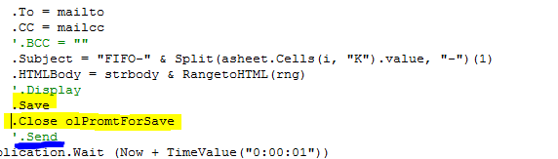

Note : do not uncomment ‘.Send it ill send mails automatically.